How to Add More Effects to the Sound Active Playlist

Background:
The façade control box runs on two playlists. One playlist is for the standard control box select. The second playlist is for sound active and audio device active

When using the software, if you look at the sound active playlist (This is done by clicking on “Play” on the bottom left corner of the software. Then, the playlist window will show up. On the upper right of the playlist window, click on the image icon until you see 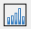. Once you see that image, it denotes the current playlist that you’re looking at is the sound active playlist). By default, the sound active playlist should have some equalizer effects. 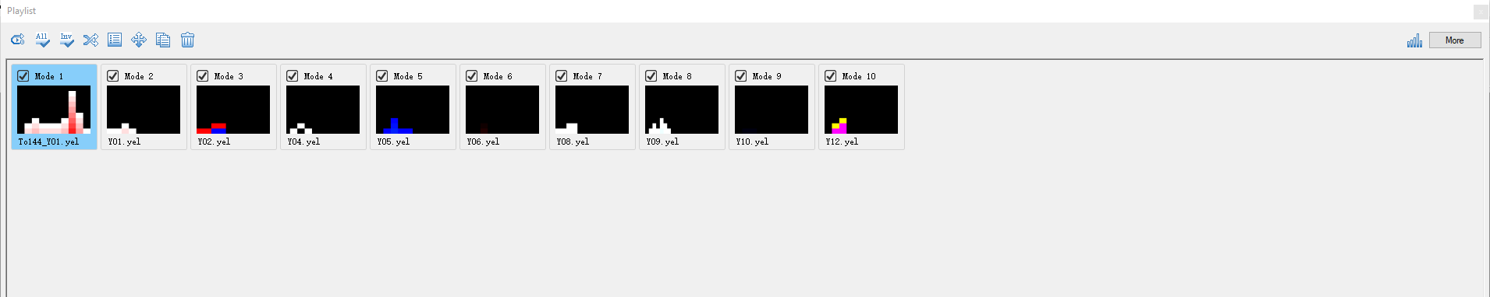

This tutorial will show you how to add more effects to the sound active playlist.

Now, referring to the playlist. If you look at each effect, you will notice the top is labelled “Mode 1” and the bottom is labelled “M001.cel”.

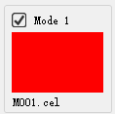

“Mode #” is the ordering number the effect is assigned to on the playlist.

“M001.cel” is the file name of the effect. You may find all the effect files in the “RGB” folder of the software’s project folder (OdysseyLEDPlayer\[Your Project Name Folder]\RGB).

To Add More Effects to the Sound Active Playlist

At the top of the software, click on the “Music” tab. Then, click on the “Convert” button.

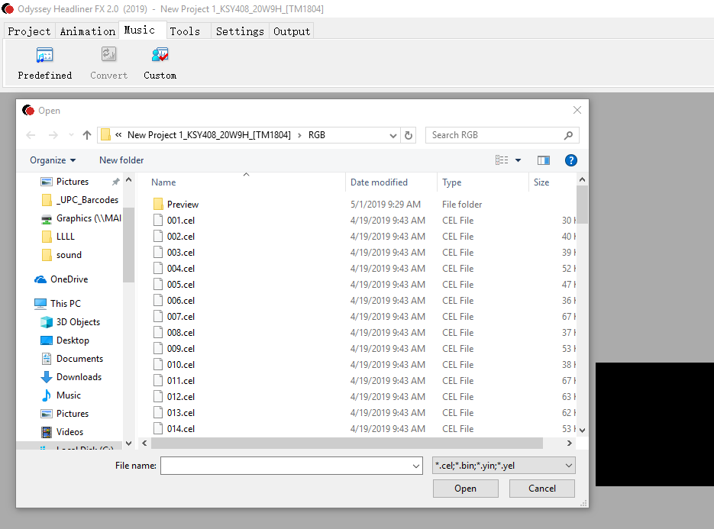

Notice, you will see a bunch of .cel files. Your playlist is composed of these .cel (effect) files Let’s go through an example.

Add More Effects to the Sound Active Playlist Example

Let’s say we have the following effects

M001.cel – the color red
M002.cel – the color green
M003.cel – the color blue
M004.cel – the color white
M005.cel – the color black

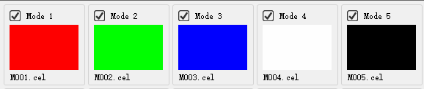
The goal is to add the green color effect to the sound active playlist.
- Go to Music -> Convert
- A window pops up. Find “M002.cel”
- Select “M002.cel” and press the “Open” button. The window will close.
It would seem nothing happened, but the green color effect has been added to the sound active playlist. You may check the sound active playlist by following the steps in the “Background” section of this tutorial.

