Control Box Settings
Before using the software, go to Settings -> Setup. Check to see if all the settings match with the image below.

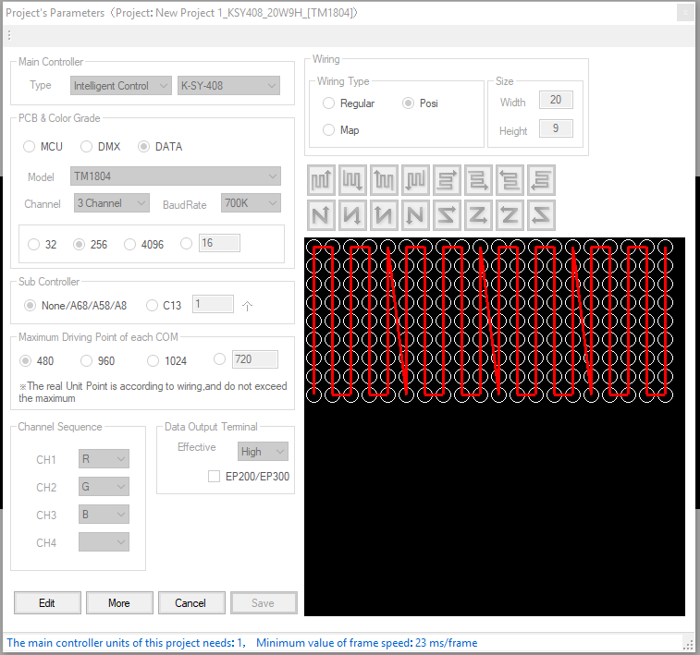

To Enlarge the Façade Preview
Your workspace should look like this. If you want to enlarge the façade preview further, go to Settings -> Param -> Display Setting Tab. In the X-Pitch and Y-Pitch boxes, enter a larger value than what’s already there. Click “OK” when done.

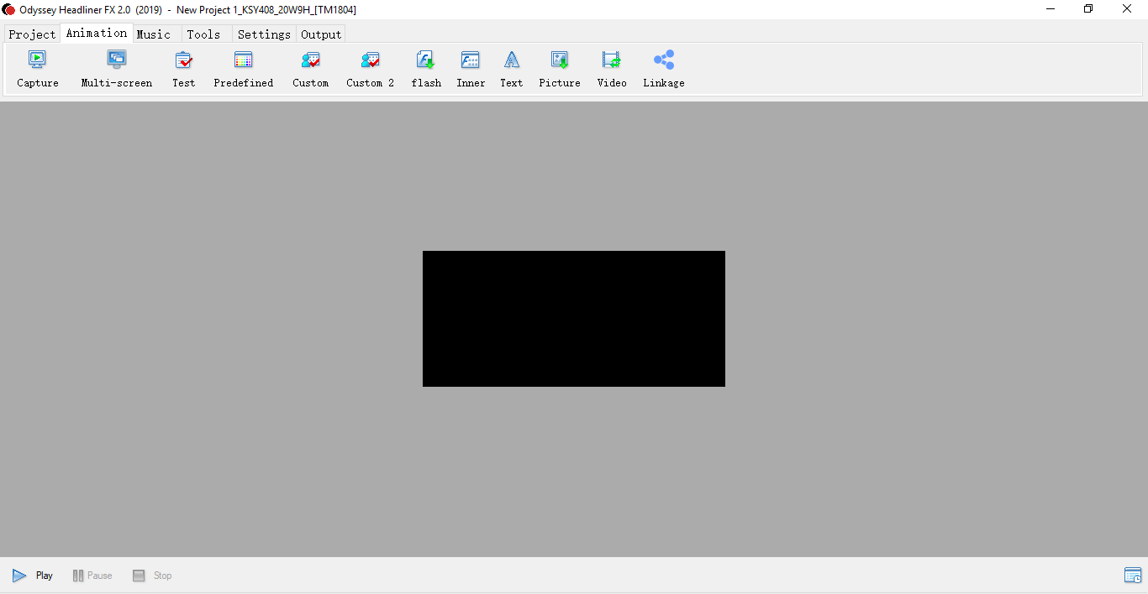

To View the Content of the Playlist
The software has two playlists for the control box. One playlist is for the control box to display the different effects. The other playlist is used when the control box is in the sound active or the audio device active mode.

To view the content of the playlists, go to the bottom left corner of the software and click the “Play” button. A new window should appear. The façade preview area should start looping through the playlist. Press “Stop” to stop the playlist preview.

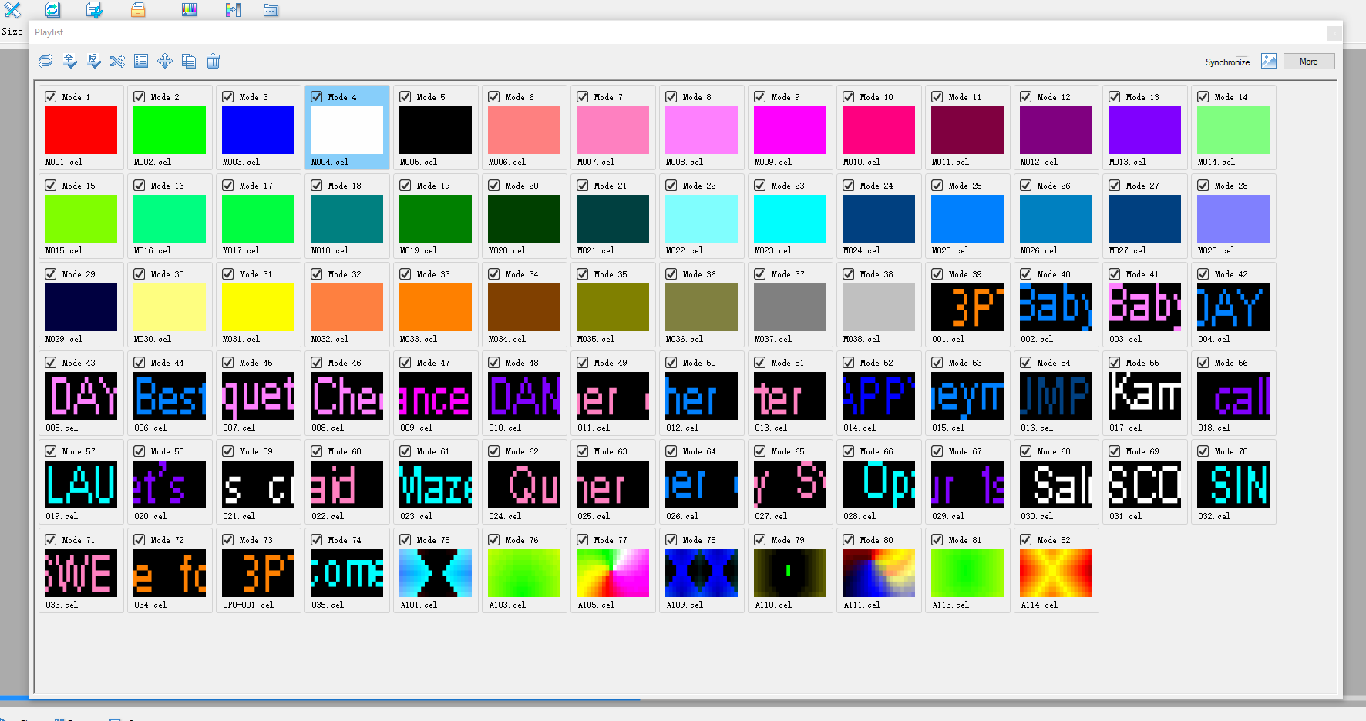

At the top right of the screen, you will see the below icons. Each time you click on the icon, a different playlist is displayed.

This icon shows the effects playlist.

This icon shows the playlist for the sound active or the audio device active mode.

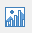 This icon shows the combined of the two playlists.

Adding Your Own Text to the Playlist
Go to Animation -> Text. Type the desire text and adjust the parameters. You should see the scrolling text on the façade preview. When finish, click “Generate”. Once clicked, you should see your custom text added to the playlist.

Adding Effects to the Playlist
The software comes with preset effects. You can find them under

Animation -> Predefined (If you want to add any of the preset effects, check the box and click “Generate” to add it to the playlist.)

Animation -> Custom (Here, you can find some effects that you may customize. Adjust the parameters to your liking and click “Generate” to add it to the playlist).

Animation -> Custom 2 (Here, you can find more effects that you may customize. Adjust the parameters to your liking and click “Generate” to add it to the playlist).

Outputting the Playlist to SD Card
Go to Output -> SD-card
Once clicked, let the software go through every effect on the playlist.

When the prompt shows “Copy SD.Bin file to SD Card?” select Yes.

The next window will show the directory path where the .bin file is stored on the local computer.

Select the drive letter of the SD card. Click “OK” and the export process will initiate.

Then, a screen will show the percentage of the output to the SD card. When finish, a “Finish” prompt will appear.

Now, in the SD card, you should see a .bin file. This is the playlist file that the control box reads. The software comes with a default .bin file located in the folder, New Project 1_KSY408_20W9H_[TM1804].

DMX Connection
With the façade control box correctly connected to the façade, you may extend the façade control with a DMX controller. Connect to the DMX controller with one of the XLR cables from the control box. For the façade, we will be using channel 1-8.

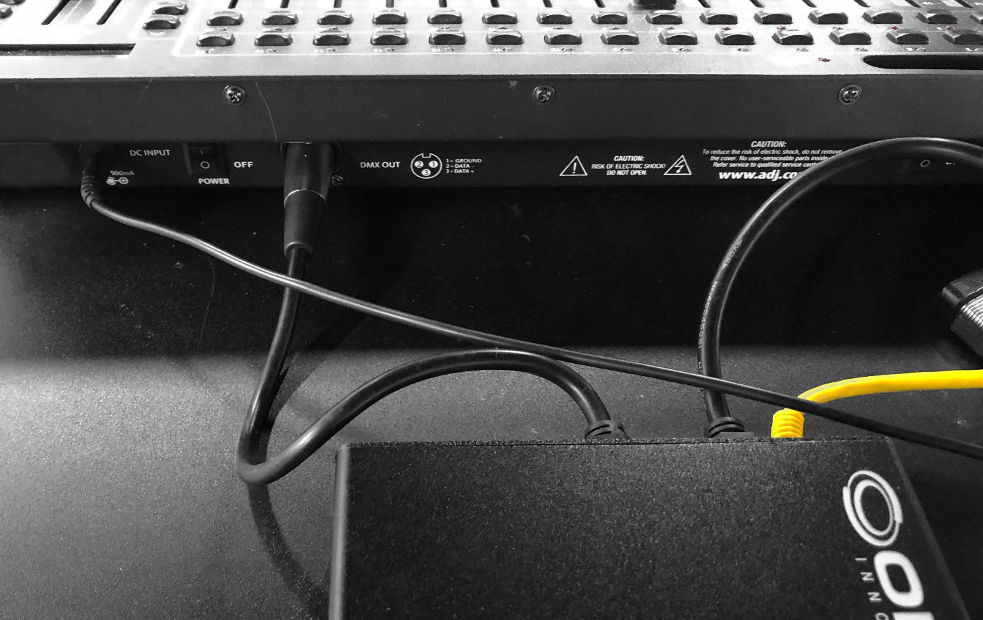

Channel 1 – Sensitivity (for sound active mode and audio device active mode)
00 (0-42)
01 (43-85)
02 (86-128)
03 (129-171)
04 (172-214)
05 (215-255)

Channel 2 – Speed

Channel 3 – Modes
00 (0-50) effects
01 (51-101) sound active – via built-in mic
02 (102-152) audio device active – via 3.5mm audio input
03 (153-203) sound active – via built-in mic
04 (204-255) audio device active – via 3.5mm audio input

The control box displays up to 99 effects. Specify the effect number using channels 4 and 5. Channel 4 controls the tenths digit of the number. Channel 5 controls the ones digit of the number. For example, if the effect is assigned to number 53, on the DMX control, set channel 4 within the range of 125-149 and channel 5 within the range of 75-99.

Channel 4 – Tenth’s digit
00 (0-24)
01 (25-49)
02 (50-74)
03 (75-99)
04 (100-124)
05 (125-149)
06 (150-174)
07 (175-199)
08 (200-224)
09 (225-255)

Channel 5 – One’s digit
00 (0-24)
01 (25-49)
02 (50-74)
03 (75-99)
04 (100-124)
05 (125-149)
06 (150-174)
07 (175-199)
08 (200-224)
09 (225-255)

Channel 6 – not used

Channel 7 – AC/DC setting. Set this to 0.
DC (0-127)
AC (128-255)

Channel 8 – Brightness (5 levels of brightness)
00 (0-42)
01 (43-85)
02 (86-128)
03 (129-171)
04 (172-214)
05 (215-255)

